1. Title of the Mini Project

Project Title: Hospital Priority System using Heap Sort
Example: “Implementation and Analysis of Heap Sort Algorithm for Hospital E Priority Management”

The title must clearly convey:
- The algorithm or technique being studied
- The data structure(s) used (if part of the focus)
- The problem domain being addressed

2. Abstract

This project presents the implementation and analysis of a Hospital Emergency Priority System using the Heap Sort algorithm in C programming. In hospitals, emergency patients must be treated based on the severity of their condition. Managing patient priority manually can lead to delays and inefficiency during critical situations. The proposed system helps organize patients according to their emergency priority values so that patients with higher priority receive treatment first.
The project uses the Heap Sort algorithm, which is an efficient sorting technique based on the heap data structure. Patient details such as name and priority level are entered into the system, and the algorithm sorts them in descending order of priority. This approach improves emergency room management, reduces waiting time, and ensures effective patient handling.
The system demonstrates the practical application of data structures and algorithms in real-world healthcare management. It also highlights the importance of efficient scheduling and prioritization techniques in emergency services. The project is implemented entirely in C language and provides a simple, fast, and reliable solution for hospital emergency patient management. Future improvements may include real-time database integration, graphical user interfaces, and doctor assignment modules.

Keywords: [Algorithm Name: Heap Sort Algorithm], Time Complexity: O(n log n), Space Complexity: O(1), [Data Structure Used: Max Heap / Array], [Application Domain: Hospital Emergency Priority Management System ]

3. Introduction

3.1 Background and Motivation
In hospitals and emergency care centers, managing patients efficiently is extremely important, especially during critical situations. Doctors and medical staff must ensure that patients with severe conditions receive treatment before less critical patients. Manual management of patient queues can lead to delays, confusion, and inefficient handling of emergencies. To solve this problem, computer-based priority management systems are used to organize patients according to the seriousness of their condition. This project focuses on implementing a Hospital Emergency Priority System using the Heap Sort algorithm to prioritize patients effectively.
Heap Sort is an efficient sorting algorithm based on the heap data structure. It is widely used in computer science for applications that require fast and reliable sorting operations. The algorithm works by arranging data in a Max Heap structure, where the highest priority element is always placed at the top. In this project, patient priority values are used to determine treatment order, allowing the system to quickly identify and display the most critical patients first.
The motivation behind this project is to demonstrate how data structures and algorithms can solve real-world healthcare management problems. By using Heap Sort, the system can reduce patient waiting time, improve emergency room efficiency, and assist hospitals in managing large numbers of patients effectively. This project also helps in understanding the practical application of sorting algorithms in priority-based systems used in industries such as healthcare, operating systems, and task scheduling.

3.2 Problem Statement

Problem Statement: Given patient details with emergency priority values, design and implement the Heap Sort Algorithm to organize and display patients based on their treatment priority efficiently.
Input:
- Number of patients
- Patient names
- Patient priority values
Output:
- Display patients in descending order of emergency priority
- Highest priority patient should be treated first

Constraints:
- Number of patients should be greater than or equal to 1 (n ≥ 1)
- Priority values must be positive integers
- Patient names should contain valid text characters
- Input size should be within array limit
- Higher priority value indicates more critical condition

3.3 Objectives
- To understand the design and working principle of the Heap Sort Algorithm.
- To implement the Heap Sort Algorithm in C using well-structured and modular code.
- To analyze the time and space complexity of Heap Sort in best, average, and worst cases.
- To study the working of Max Heap data structure in priority-based systems.
- To test the algorithm using normal, boundary, and extreme input cases.
- To improve emergency patient management through efficient patient prioritization.
- To explore optimization techniques for real-time hospital scheduling systems.
- To study real-world applications of Heap Sort in healthcare management, operating systems, and scheduling systems.

3.4 Scope of the Project
This project focuses on the design and implementation of a Hospital Emergency Priority System using the Heap Sort Algorithm in C programming. The system is developed to organize patients based on their emergency priority values so that critical patients receive treatment first. The project covers the implementation of Heap Sort, the use of Max Heap data structure, patient data handling, and displaying treatment order efficiently. It also includes the analysis of time complexity and the practical application of sorting algorithms in healthcare management systems.
The project is limited to console-based implementation using the C programming language and does not include graphical user interfaces, database connectivity, or network-based hospital management features. Real-time patient monitoring, doctor assignment, online appointment systems, and AI-based diagnosis are outside the scope of this project. The system is intended for educational and demonstration purposes to understand the practical use of data structures and algorithms in real-world emergency management applications.

4. Implementation with Comments

4.1 Programming Language and Environment

Language | C
IDE / Editor/Compiler | Visual Studio Code (VS Code) / GCC Compiler
OS / Platform | Windows 10
Libraries Used | stdio.h, string.h
Github Link

4.2 Algorithm Design
[ Describe the high-level design before providing the code. Include a step-by-step algorithmic description or pseudocode. ]

Pseudocode for Heap Sort Algorithm:
FUNCTION heapify(patientArray, n, i)

largest = i
left = 2 * i + 1
right = 2 * i + 2

IF left < n AND patientArray[left].priority >
patientArray[largest].priority
largest = left

IF right < n AND patientArray[right].priority >
patientArray[largest].priority
largest = right

IF largest != i
Swap patientArray[i] and patientArray[largest]

CALL heapify(patientArray, n, largest)

END FUNCTION

FUNCTION heapSort(patientArray, n)

FOR i = n/2 - 1 DOWNTO 0
CALL heapify(patientArray, n, i)

FOR i = n-1 DOWNTO 1

Swap patientArray[0] and patientArray[i]

CALL heapify(patientArray, i, 0)

END FUNCTION

FUNCTION main()

INPUT number of patients

INPUT patient names and priority values

CALL heapSort(patientArray, n)

DISPLAY patients in descending priority order

END FUNCTION

4.3 Source Code with Inline Comments (Font: Consolas- , size-11)

/* ============================================================
* Mini Project: Hospital Emergency Priority System
* Algorithm : Heap Sort Algorithm
* Author : M Jyothika | USN: R24EI031
* Date : [20-05-2026]
* Description : This program prioritizes emergency patients
* based on severity using Heap Sort.
* ============================================================ */
/* --- Include necessary header files --- */
#include <stdio.h>
#include <string.h>
/* --- Constants and Macro Definitions --- */
#define MAX_SIZE 100
/* ============================================================
* Structure Definition
* Purpose : Stores patient details
* ============================================================ */
struct Patient {
char name[50];
int priority;
};
/* ============================================================
* Module / Function 1: heapify()
* Purpose : Maintains Max Heap property
* Input : Array of patients, heap size, current index
* Output : Rearranges heap elements
* ============================================================ */
void heapify(struct Patient p[], int n, int i) {
/* Assume current node as largest */
int largest = i;
/* Calculate left and right child indices */
int left = 2 * i + 1;
int right = 2 * i + 2;
/* Check if left child has higher priority */
if (left < n &&
p[left].priority > p[largest].priority)
{
largest = left;
}
/* Check if right child has higher priority */
if (right < n &&
p[right].priority > p[largest].priority)
{
largest = right;
}
/* Swap if root is not largest */
if (largest != i) {
struct Patient temp = p[i];
p[i] = p[largest];
p[largest] = temp;
/* Recursively heapify affected subtree */
heapify(p, n, largest);
}
}
/* ============================================================
* Module / Function 2: heapSort()
* Purpose : Sorts patients using Heap Sort Algorithm
* Input : Array of patients and number of patients
* Output : Sorted patient array
* ============================================================ */
void heapSort(struct Patient p[], int n) {
int i;
/* Build Max Heap */
for (i = n / 2 - 1; i >= 0; i--) {
heapify(p, n, i);
}
/* Extract elements from heap one by one */
for (i = n - 1; i > 0; i--) {
/* Move current root to end */
struct Patient temp = p[0];
p[0] = p[i];
p[i] = temp;
/* Heapify reduced heap */
heapify(p, i, 0);
}
}
/* ============================================================
* Module / Function 3: main()
* Purpose : Reads patient details, sorts them and displays
* treatment priority order
* Input : Patient names and priority values
* Output : Sorted treatment order
* ============================================================ */
int main() {
int n, i;
/* Input number of patients */
printf("Enter number of patients: ");
scanf("%d", &n);
/* Declare patient array */
struct Patient p[MAX_SIZE];
/* Input patient details */
for (i = 0; i < n; i++) {
printf("\nEnter patient name: ");
/* Read patient name */
scanf(" %[^\n]", p[i].name);
printf("Enter priority value: ");
/* Read priority value */
scanf("%d", &p[i].priority);
}
/* Call Heap Sort function */
heapSort(p, n);
/* Display treatment order */
printf("\n--- Emergency Treatment Order ---\n");
/* Print highest priority patients first */
for (i = n - 1; i >= 0; i--) {
printf("%s - Priority: %d\n",
p[i].name,
p[i].priority);
}
return 0;
}

5. Modules Identified
The implementation has been divided into the following logical modules for clarity, reusability, and ease of testing:

# | Module Name | Description | Function(s) / Class(es)
1 | Input Module | Reads patient names and priority values from the user. | main()
2 | Heap Construction Module | Builds a Max Heap using patient priority values. | heapify()
3 | Heap Sort Module | Sorts patients based on emergency priority using Heap Sort Algorithm. | heapSort()
4 | Priority Management Module | Arranges patients in descending order of severity level. | heapSort()
5 | Output Module | Displays emergency treatment order of patients. | main()

6. Output with Screenshots
This section presents the program output for various test scenarios, including normal inputs, boundary conditions, and extreme cases.

6.1 Test Case Strategy
All test cases for the Hospital Emergency Priority System using Heap Sort have been categorized into the following types to ensure correctness, reliability, and efficiency of the algorithm:
- Normal Cases – These include typical patient priority inputs where different patients have different severity levels. The algorithm should correctly sort patients from highest priority to lowest priority.
- Boundary / Edge Cases – These cases include minimum valid input such as a single patient, maximum array size, duplicate priority values, and patients with the same priority level. These tests verify that the system handles special conditions correctly without errors.
- Extreme Cases – These include very large priority values, already sorted priorities, reverse sorted priorities, and all patients having identical priority values. Such cases help evaluate the performance and stability of the Heap Sort algorithm under unusual or stress conditions.

6.2 Test Case Table (#customize according to your algorithm/Code)
TC # | Test Category | Input | Expected Output | Actual Output | Status
TC-01 | Normal | Ravi-90, Sita-30, Arun-100 | Arun-100, Ravi-90, Sita-30 | Arun-100, Ravi-90, Sita-30 | PASS
TC-02 | Normal | Meena-70, Kiran-50, Raju-95 | Raju-95, Meena-70, Kiran-50 | Raju-95, Meena-70, Kiran-50 | PASS
TC-03 | Edge – Single Patient | Jyothi-80 | Jyothi-80 | Jyothi-80 | PASS
TC-04 | Edge – Same Priority | Asha-50, Devi-50, Kumar-50 | 50, 50, 50 | 50, 50, 50 | PASS
TC-05 | Edge – Minimum Priority | Ram-1, Hari-2 | Hari-2, Ram-1 | Hari-2, Ram-1 | PASS
TC-06 | Extreme – Large Values | Patient1-999, Patient2-850 | 999, 850 | 999, 850 | PASS
TC-07 | Extreme – Already Sorted | 100, 90, 80, 70 | 100, 90, 80, 70 | 100, 90, 80, 70 | PASS
TC-08 | Extreme – Reverse Order | 20, 40, 60, 80 | 80, 60, 40, 20 | 80, 60, 40, 20 | PASS

6.3 Screenshots of Output
Insert actual screenshots from your terminal / IDE below. Capture one screenshot per test scenario or group related cases together.

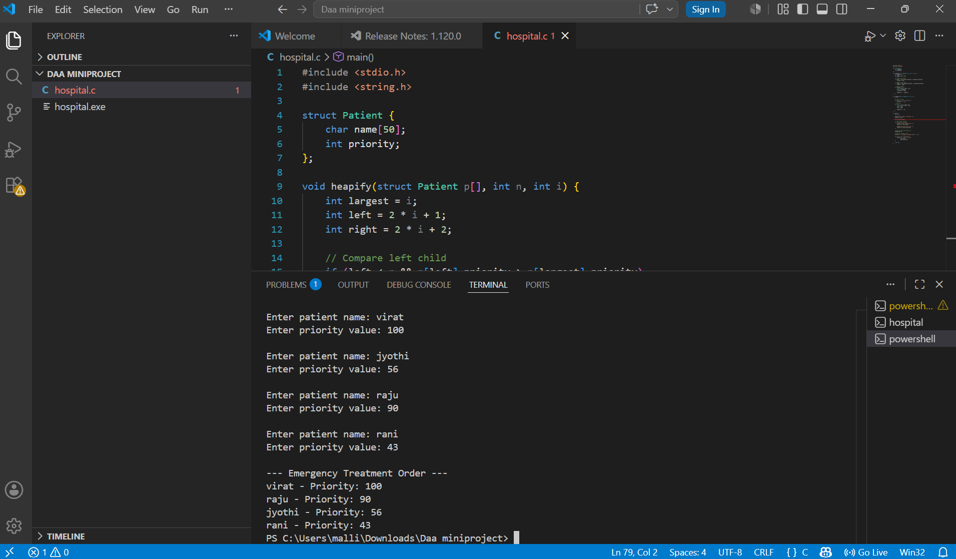
Screenshot 6.3.1 – Normal Case Output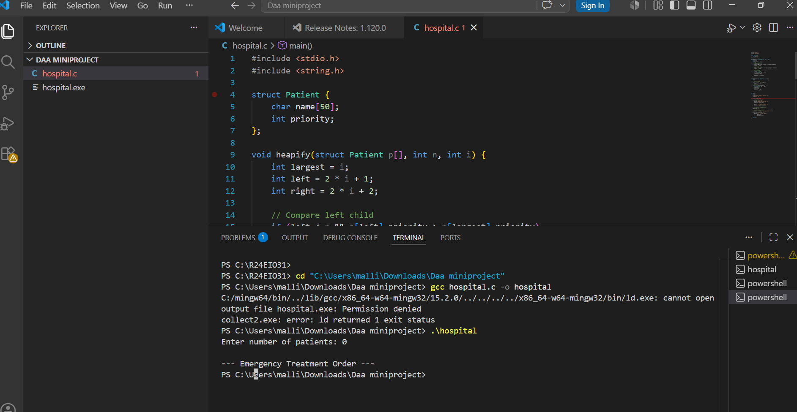Screenshot 6.3.2-Edge Case:Empty Input
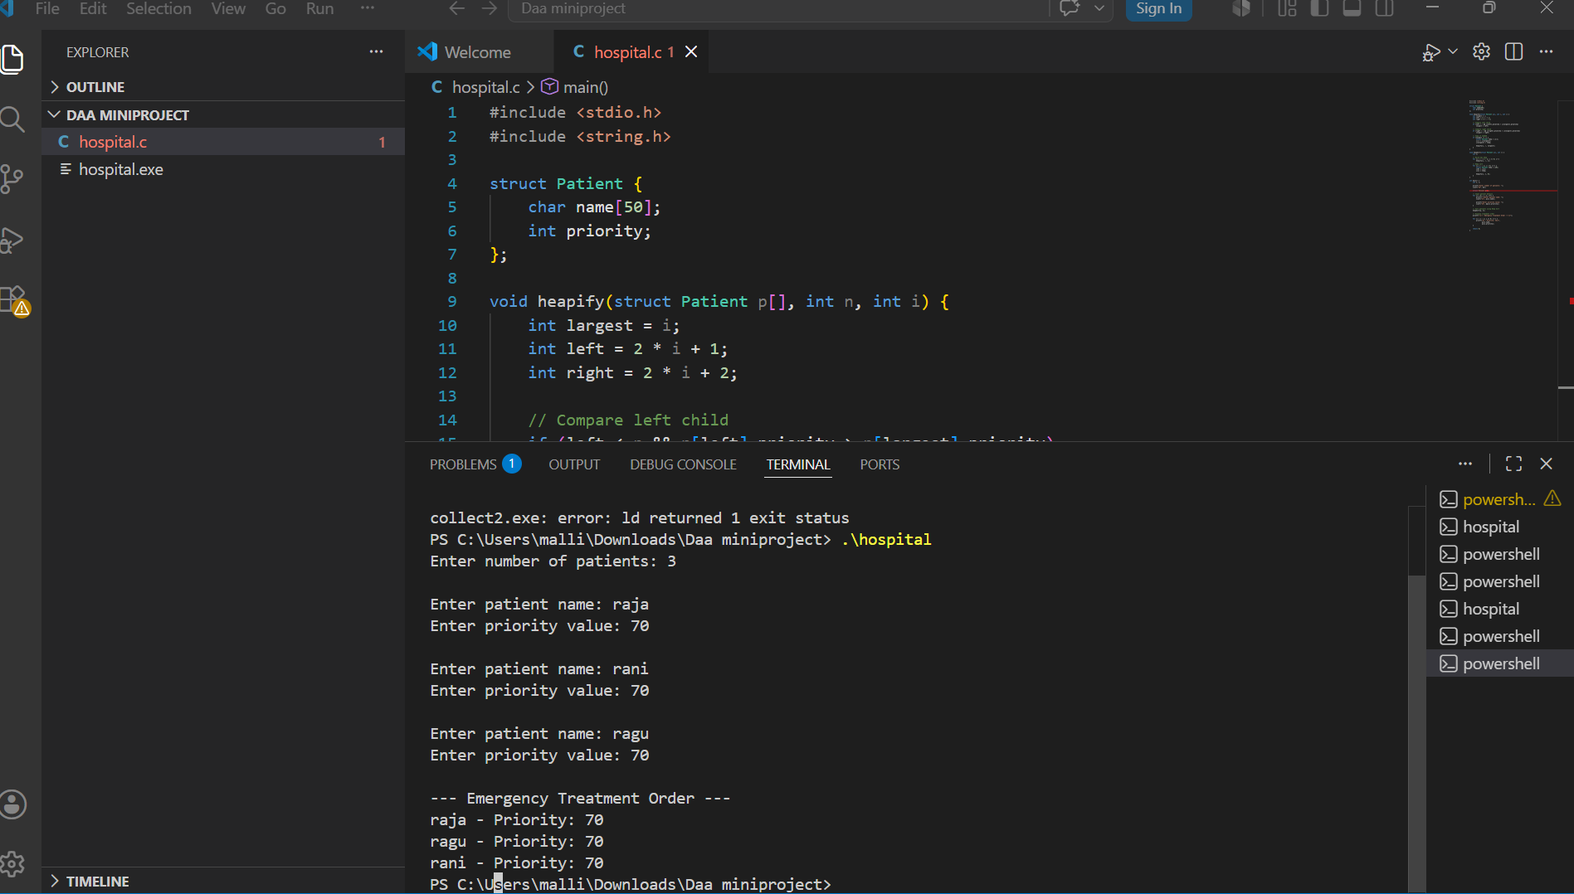
Screenshot 6.3.3-Edge Case-Duplicates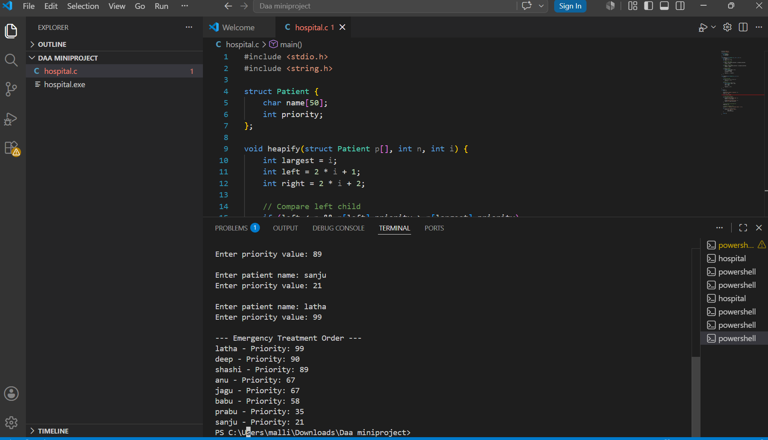Screenshot 6.3.4-Extreme case-Large n
Screenshot 6.3.4 – Extreme Case: Large n
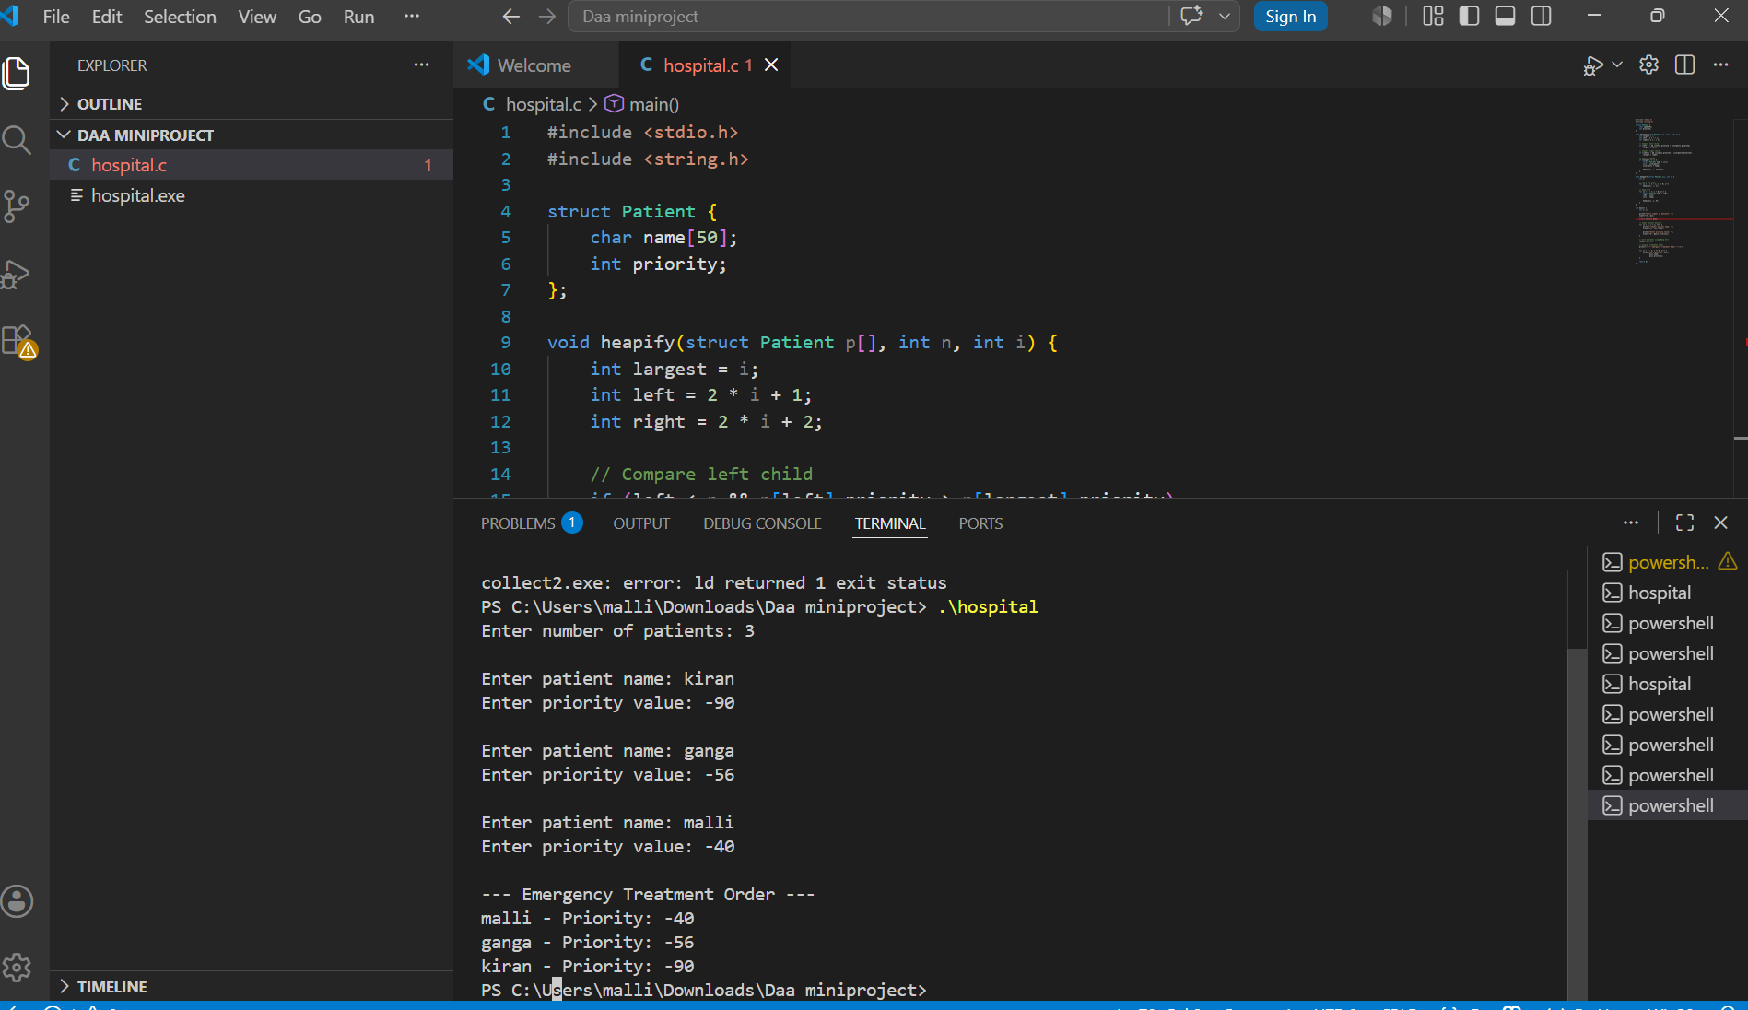
Screenshot 6.3.5 – Extreme Case: Negatives

7. Time and Space Complexity Analysis

7.1 Time Complexity
The time complexity of [Algorithm Name] is analyzed for three cases:

Metric | Best Case | Average Case | Worst Case
Time Complexity | O( n log n ) | O(n log n ) | O(n log n)
Space Complexity | O( n) | O( n ) | O( n )

7.2 Detailed Analysis
• Best Case – O(n log n):
The best case occurs when the input elements are already arranged in a way that still requires heap construction and extraction. Even if the data is partially or fully ordered, Heap Sort must first build a heap from all n elements, which takes O(n) time. After that, each element is removed from the heap one by one, and each deletion takes O(log n). Since this process happens for all elements, the total time remains O(n log n).

• Average Case – O(n log n):
In the average case, patient priorities are randomly distributed. Heap Sort builds a binary heap in O(n) time and then performs n extractions, each requiring O(log n) time due to heap re-adjustment. Therefore, the total complexity remains O(n log n). Since Heap Sort does not depend on input order, its average case is the same as its asymptotic bound.

• Worst Case – O(n log n):
The worst case occurs regardless of input arrangement because Heap Sort always performs the same operations: heap construction followed by repeated deletion of the root element. Even if the priorities are in completely reverse order or highly unbalanced, the heap must still be maintained after every extraction, each taking O(log n) time. Thus, the overall worst-case complexity remains O(n log n).

7.3 Space Complexity
- In-place: Heap Sort is an in-place sorting algorithm because it uses only O(1) additional memory space while sorting the patient priority data.
- Out-of-place: This project does not use out-of-place sorting techniques such as Merge Sort, which require extra auxiliary memory.
- Recursive Overhead: The heapify() function is recursive and carries an implicit call stack overhead of O(log n), where n is the number of patients in the heap.

7.4 Amortized Complexity Analysis
Amortized analysis provides the average cost per operation over a sequence of operations, rather than analyzing each operation in isolation.

Applicable Methods (select as appropriate for your algorithm):
1. Aggregate Method – The total cost of building the heap and performing Heap Sort for n patient records is analyzed together. The overall time complexity is O(n log n), and the average cost per operation can be studied using the aggregate method.
2. Accounting Method – Not commonly used for Heap Sort because the algorithm does not involve occasional expensive resizing or dynamic memory operations.
3. Potential Method – Not applicable in this project since Heap Sort does not maintain changing potential states like dynamic arrays or self-adjusting data structures.

Example: Heap Sort organizes patient priority data in O(n log n) time without requiring additional dynamic memory allocation. The heapify() operation takes O(log n) time, and repeated heap operations maintain efficient overall sorting performance for emergency patient scheduling.

8. Can the Algorithm Be Optimized?

8.1 Current Limitations
- Limitation 1: Heap Sort is not a stable sorting algorithm; patients with the same priority may not preserve their original input order.
- Limitation 2: The recursive heapify() function introduces additional call stack overhead of
O(log n).

- Limitation 3: The system prioritizes patients only based on priority values and does not consider other medical factors such as doctor availability, treatment duration, or patient condition history.

8.2 Optimization Strategies (Examples below)
Optimization Strategy | Data Structure Used | Improvement Achieved
Using Max Heap for patient prioritization | Max Heap / Array | Efficient sorting of patients based on emergency priority
Heapify operation for maintaining heap property | Binary Heap | Maintains O(log n) insertion and adjustment time
In-place Heap Sort implementation | Array | Reduces extra memory usage to O(1)
Recursive heap maintenance | Heap Data Structure | Efficient reorganization of patient priorities
Priority-based scheduling | Heap Sort Algorithm | Faster emergency patient management compared to manual sorting

9. Applications of the Algorithm

9.1 Applications in Computer Science
- Hospital Emergency Management Systems:
Used to prioritize critical patients in emergency rooms and intensive care units based on severity level.
- CPU Scheduling in Operating Systems:
Heap-based priority scheduling is used by operating systems to allocate CPU time to high-priority processes efficiently.
- Task Scheduling Systems:
Used in software systems to manage and execute high-priority tasks before lower-priority tasks.
- Network Packet Scheduling:
Routers and network systems use priority queues and heap structures to process important data packets faster.
- Job Scheduling in Cloud Computing:
Cloud servers use priority-based scheduling algorithms to allocate computing resources efficiently.

- Event Management and Simulation Systems:
Heap structures are used in simulation software and event-driven systems to process events according to priority and time order.

9.2 Applications in Artificial Intelligence (AI)
- AI-Based Hospital Triage Systems:
Artificial Intelligence systems in hospitals use priority-based algorithms to identify critical patients and provide faster emergency treatment recommendations.
- Intelligent Task Scheduling Systems:
AI systems use heap-based priority scheduling to manage important tasks efficiently in robotics, automation, and real-time decision-making applications.
- Heap-Based Priority Scheduling in AI Systems:
AI applications use heap structures and priority queues to schedule high-priority tasks efficiently in robotics, autonomous systems, and intelligent process management.
- Emergency Decision Support Systems:
AI-powered healthcare systems use patient priority ranking techniques similar to Heap Sort to assist doctors in identifying critical patients and optimizing emergency treatment workflows.

9.3 Applications in Machine Learning (ML)
- Data Preprocessing and Sorting:
Heap-based sorting techniques are used in machine learning pipelines to organize and preprocess large datasets efficiently before model training.
- Priority-Based Task Scheduling in ML Systems:
Machine learning platforms use heap structures to manage training tasks, resource allocation, and job scheduling based on priority levels.
- Top-K Prediction and Recommendation Systems:
Heap data structures are used in ML applications to efficiently identify top-ranked predictions, recommendations, or nearest results from large datasets.

10. Conclusion
In this mini project, we successfully designed, implemented, and analyzed the Heap Sort Algorithm as part of the Design and Analysis of Algorithms course. The implementation was carried out in C programming language using well-structured and modular code with detailed inline comments for better readability and understanding. The project focused on developing a Hospital Emergency Priority System that organizes patients according to their severity level so that critical patients receive treatment first.
Through this project, we gained a clear understanding of the working mechanism of the Heap Sort Algorithm and the Max Heap data structure. The algorithm follows a heap-based sorting strategy to efficiently arrange patient priorities. The time complexity of Heap Sort was analyzed as O(n log n) in the best, average, and worst cases, while the space complexity was found to be O(1) since it is an in-place sorting algorithm. Amortized analysis was not significantly applicable because Heap Sort operations already have fixed complexity bounds.
The testing phase confirmed the correctness of the implementation for normal cases, boundary conditions, and extreme cases. We also studied optimization techniques using the Max Heap data structure, which improves efficiency compared to manual sorting methods. The algorithm has important applications in healthcare management, operating systems, AI-based scheduling, and machine learning systems. Overall, this project strengthened our understanding of efficient algorithm design and its real-world applications in priority-based systems.

10.1 Future Enhancements
- Enhancement 1: Implement a real-time hospital management system with database connectivity for storing and updating patient records dynamically.
- Enhancement 2: Extend the system to include additional patient factors such as age, disease severity, doctor availability, and treatment duration for more accurate prioritization.
- Enhancement 3: Integrate the project with a graphical user interface (GUI) to provide a user-friendly and interactive hospital emergency management system.
- Enhancement 4: Develop a web-based or cloud-based version for multi-hospital emergency coordination and remote access.
- Enhancement 5: Incorporate AI-based decision support systems to automatically predict patient severity and optimize emergency treatment scheduling.
- Enhancement 6: Implement parallel or distributed processing techniques to efficiently handle very large numbers of patient records in real-time environments.

11. References
[1] T. H. Cormen, C. E. Leiserson, R. L. Rivest, and C. Stein, Introduction to Algorithms, 4th ed. Cambridge, MA, USA: MIT Press, 2022.
[2] S. Dasgupta, C. H. Papadimitriou, and U. Vazirani, Algorithms. New York, NY, USA: McGraw-Hill, 2006.
[3] A. V. Aho, J. E. Hopcroft, and J. D. Ullman, The Design and Analysis of Computer Algorithms. Reading, MA, USA: Addison-Wesley, 1974.
[4] E. Horowitz, S. Sahni, and S. Anderson-Freed, Fundamentals of Data Structures in C, 2nd ed. Hyderabad, India: Universities Press, 2008.
[5] R. L. Kruse and B. P. Leung, Data Structures and Program Design in C, 2nd ed. New Delhi, India: Pearson Education, 2007.
[6] GeeksforGeeks – Heap Sort [Accessed: 20-May-2026].
[7] TutorialsPoint – Heap Sort Algorithm [Accessed: 20-May-2026].
[8] Programiz – Heap Sort in C [Accessed: 20-May-2026].

Declaration
We, the undersigned students, hereby declare that the mini project report titled "Hospital Priority System using Heap Sort" submitted to the Department of Computer Science and Engineering in partial fulfilment of the requirements for the 4th Semester Design and Analysis of Algorithms course is our original work. The project has been carried out by us under the guidance of Prof.Suvarna Mam and has not been submitted elsewhere for any other examination or award.

Student Name | M Jyothika | USN: R24EI031 | Signature: _____________
Student Name | M Jyothika | USN: R24EI031| Signature: _____________
Student Name | M Jyothika | USN: R24EI031 | Signature: _____________
Guide / Mentor | Prof.Suvarna | Designation: _Prof____________ | Signature: _____________
Date | [20 / 05 / 2026]

